Spectroscopic Ellipsometry Analysis for Parul’s OTS Process

Jovan Trujillo
Arizona State University
Flexible Display Center
12/22/2006

Bare silicon wafer with thermal oxide

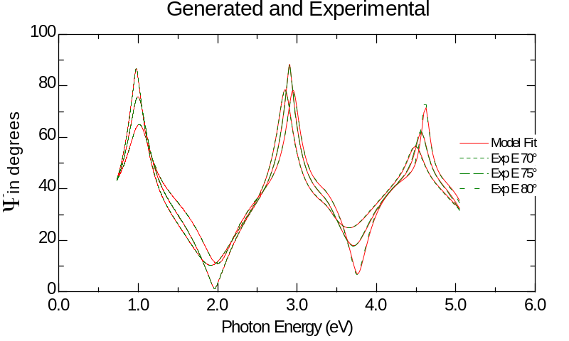

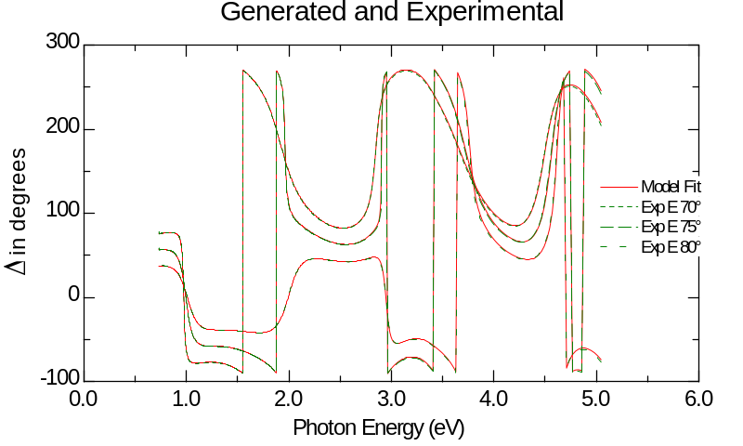

Used models provided in software for fit. These are si_jaw for silicon substrate and sio2_jaw for thermal oxide layer. These models were developed by J. A. Woollam. Thermal oxide is 2874.94 ± 0.0919 Å. MSE = 21.63.

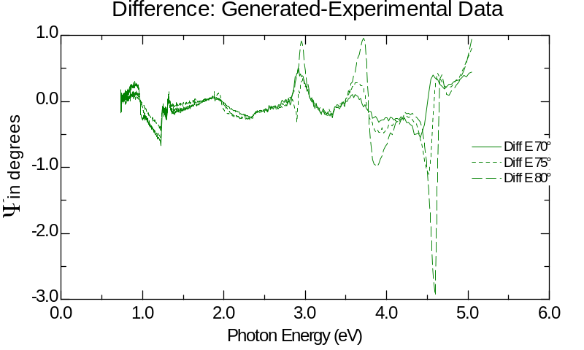
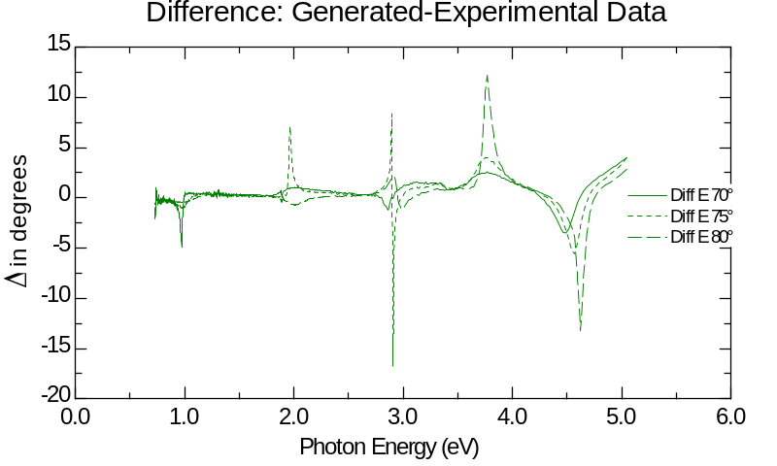

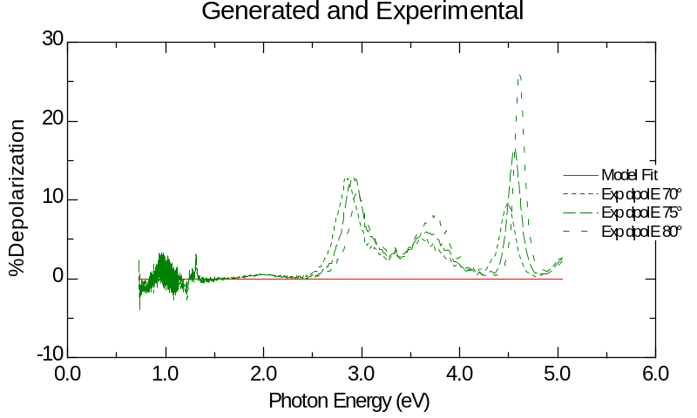

OTS treated silicon reference #20

Comparison to previous model of silicon oxide only

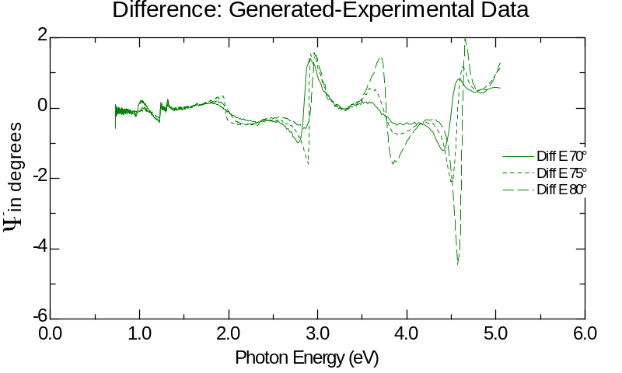

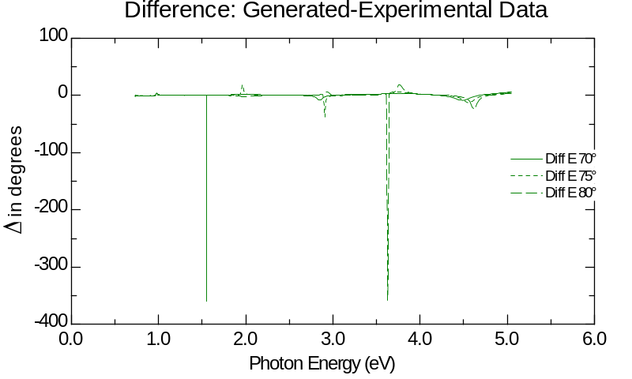

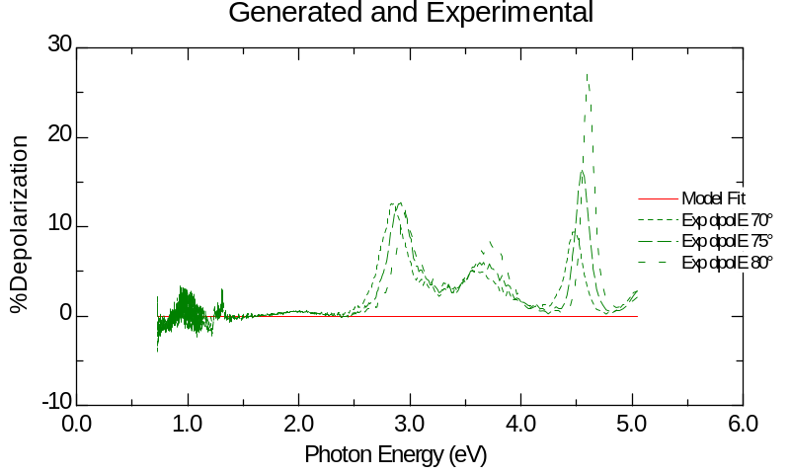

With Cauchy layer added to SiO₂ layer.

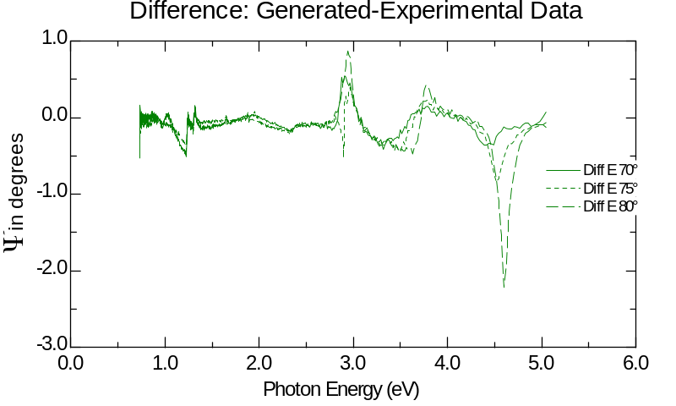
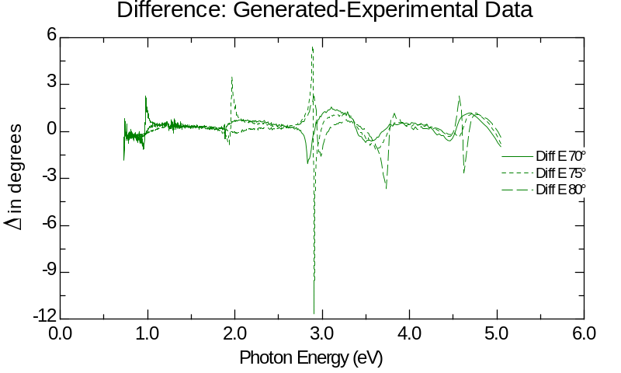

Cauchy fit gives thicknes of 32.96 ± 0.512. MSE = 12.68. Note that fitting this model to bare silicon with thermal oxide gave 109.68 ± 28.7 Å, MSE = 13.68.

If a light bandwidth of 6.0534 nm is added to account for some of depolarization at high energy, Cauchy fit gives 32.65 ± 8.85 Å, MSE = 12.87. Depolarization plot of bare Si/SiO₂ wafer with extra Cauchy layer looks like this:

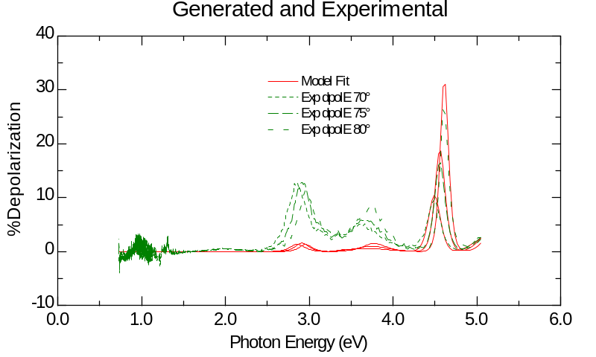

Ellipsometer consistently shows strong depolarization peaks near 3.0 eV, 3.8 eV, and 4.6 eV. This confounds the signal I’m getting from the films. Non-ideal model of OTS #20 sample looks like this:

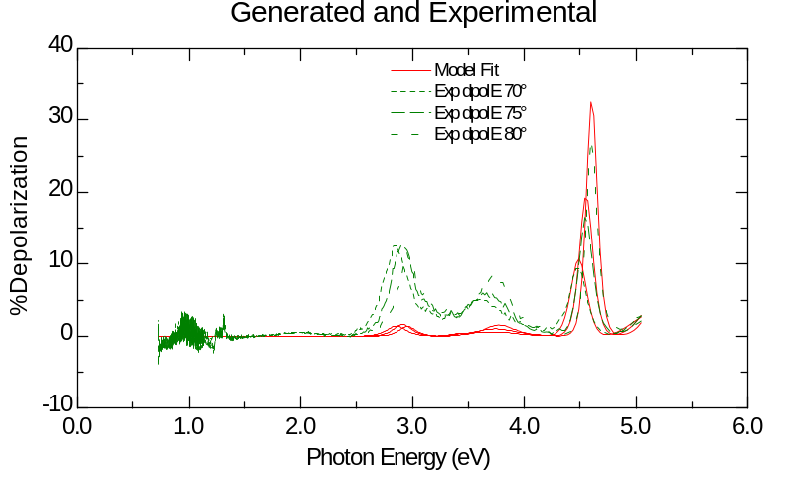

This seems to be the same and the last sample. It seems that there are imperfections in the light filtering system on the M-2000. Cauchy fit of Non-ideal model is 23.55 ± 1.36 Å, MSE = 11.64. Other plots of this model include:

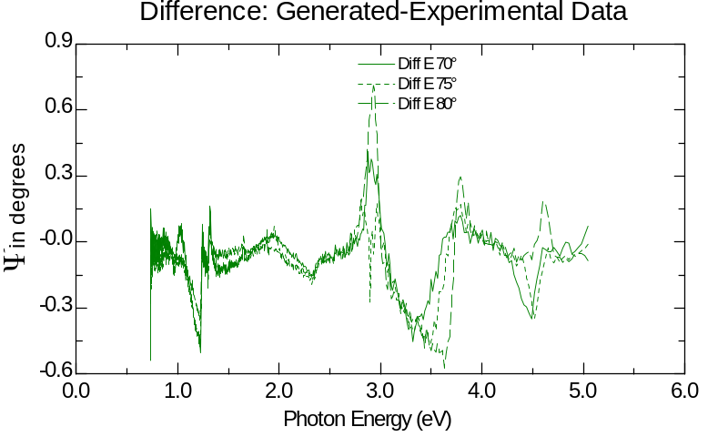

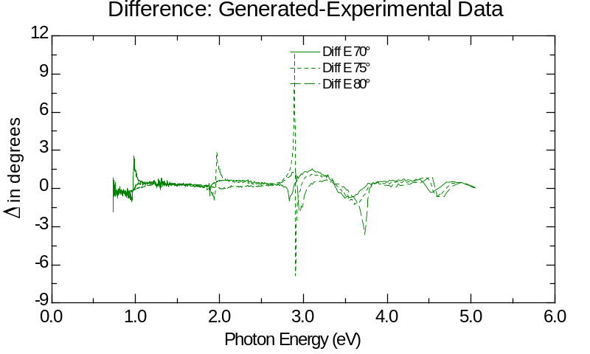

OTS treated silicon reference #25

Same Cauchy fit on top of 2874.94 Å SiO₂ and Si substrate. Non-ideal light bandwidth of 6.139 nm was added to account for depolarization. Cauchy fit gave 21.69 ± 0.847 Å, MSE = 11.51. Plots follow:

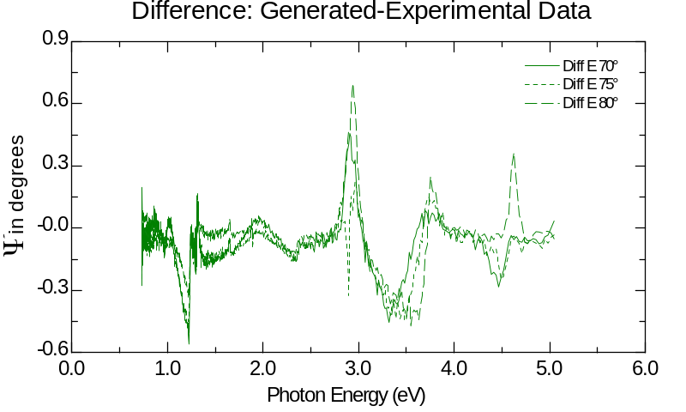

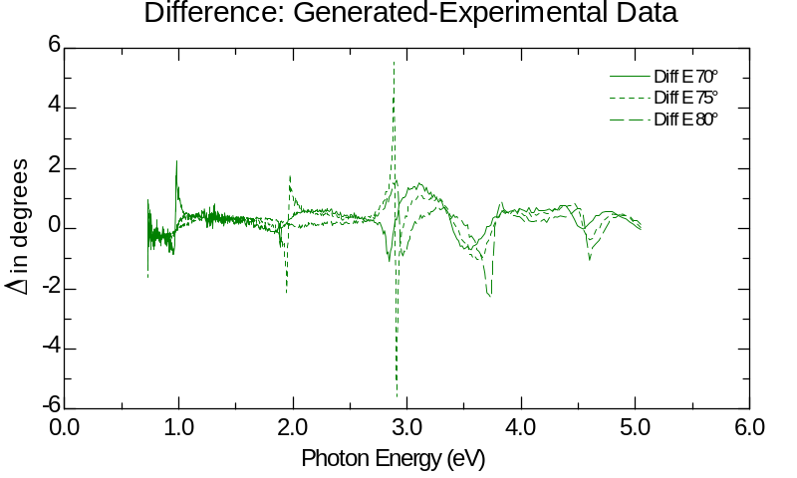

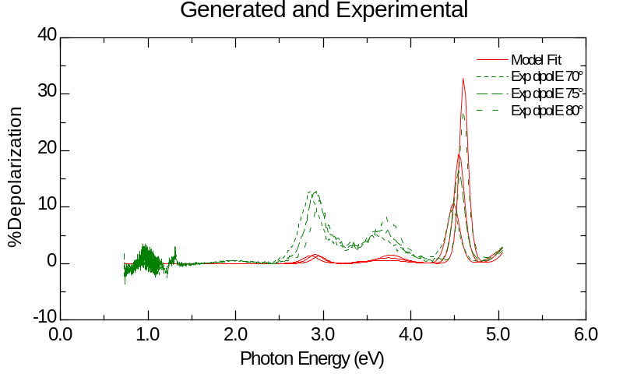
New Approach to the problem

Bare SiO₂/Silicon Wafer

Previous measurements of OTS on SiO₂ showed that there is an extra monolayer of “crud” on the bare SiO₂/Si wafers. Therefore in this approach four parameters were varied in modeling the bare SiO₂/Si wafer. The top-bottom order of the layers is:

Cauchy->sio2_jaw->si_jaw
The variables are sio2_jaw thickness, Cauchy thickness, Cauchy An coefficient, and finally light bandwidth. This created a significantly lower mean square error, dropping from MSE = 21.63 to MSE = 9.592. The results are:

Sio2_jaw thickness: 2866.98 ± 0.214 Å
Cauchy thickness: 30.94 ± 0.288 Å
Cauchy An coefficient: 1.08 ± 0.00343
Light bandwidth: 6.1813 ± 0.12 nm
MSE = 9.592

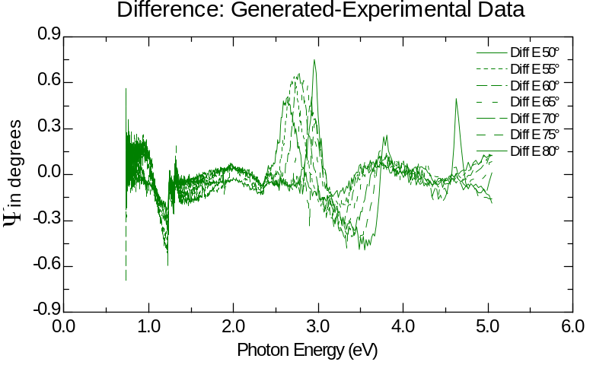

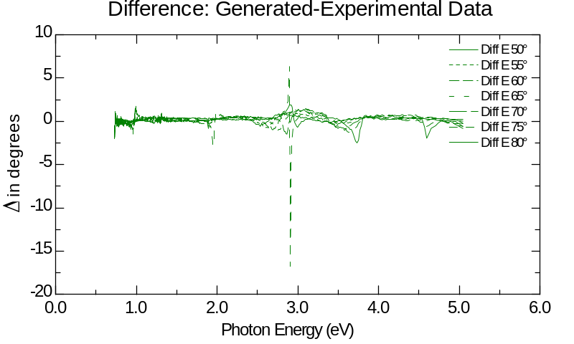
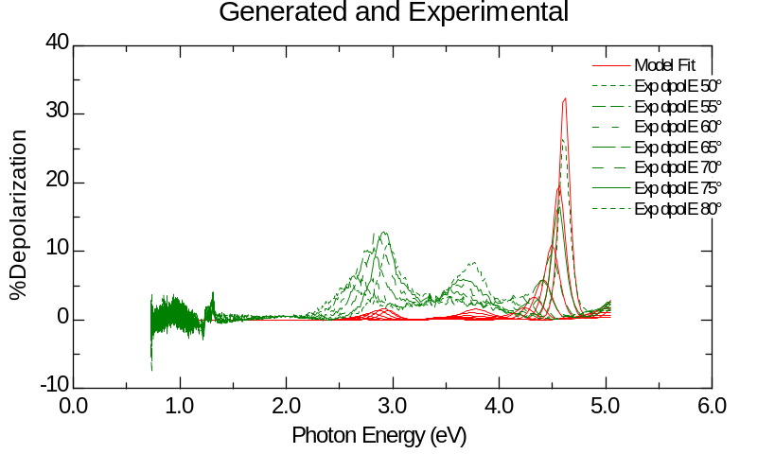
Increasing the number of angles used to overspecify the problem also reduces the MSE. Redoing this analysis for 3 angles around the Brewster angle gave an MSE = 11.32. Still half of what was given using only the sio2_jaw layer.

This model was then used on the OTS treated wafers, assuming that the thermal oxide thickness is now a constant.

OTS treatment on SiO₂/Si wafer reference #20

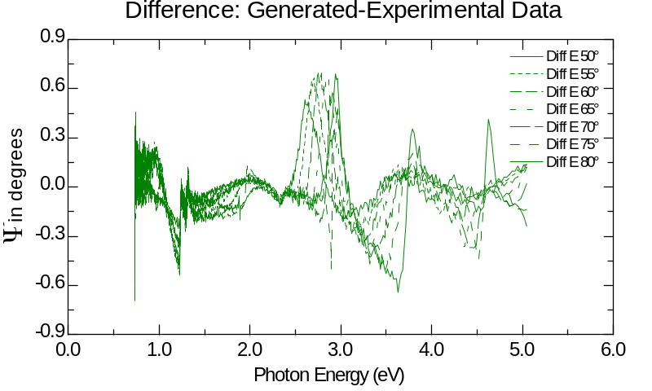

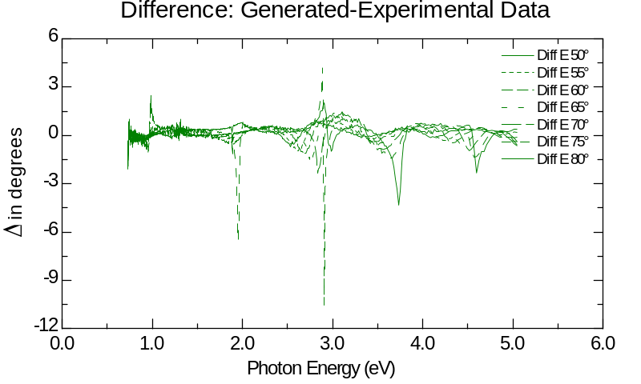

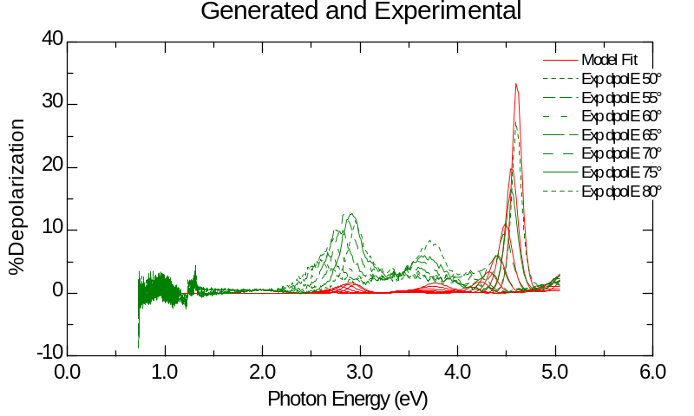

Variables fitted:

Cauchy thickness: 31.39 ± 0.275 Å
Cauchy An coefficient: 1.1246 ± 0.00161
Light bandwidth: 6.2613 ± 0.124 nm

It does not seem that there is a monolayer on this sample.

OTS treatment on SiO₂/Si wafer reference #25

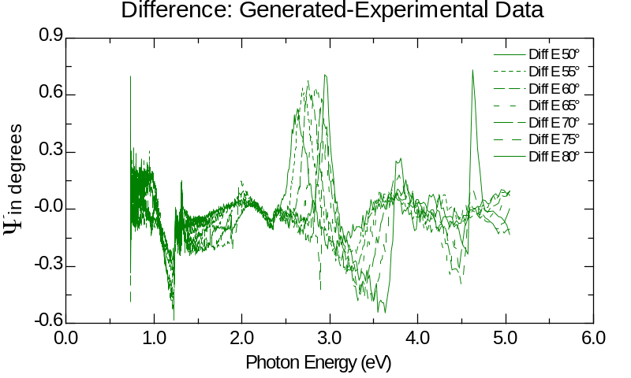

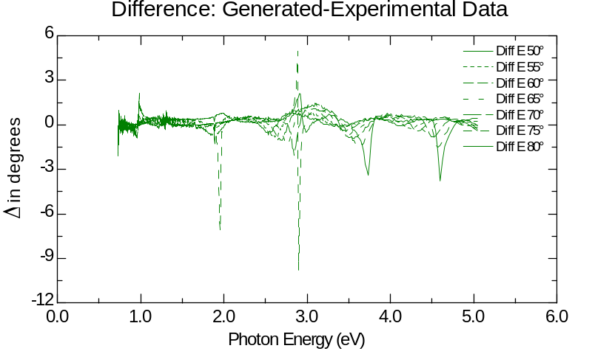

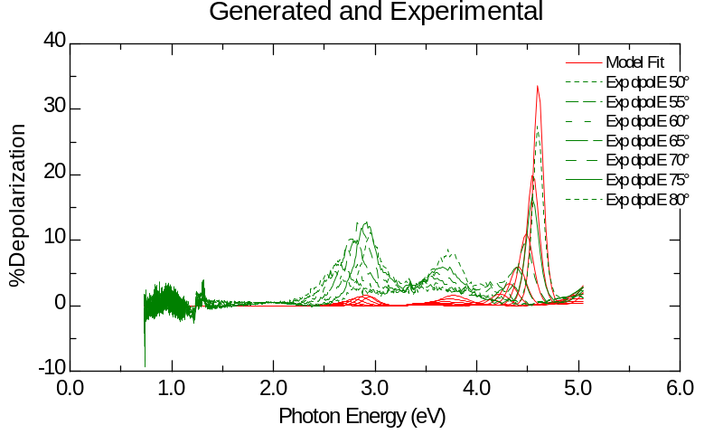

Variables fit:

Cauchy thickness: 30.57 ± 0.251 Å
Cauchy An coefficient: 1.1598 ± 0.00179
Light bandwidth: 6.2509 ± 0.126 nm
MSE = 10.13

Again the monolayer could not be detected.

Comparison to previous samples measured

Using the current methodology the previous samples was studied again.

Parul_sio2_11022006 sample

Variables fitted:

Cauchy thickness: 19.22 ± 0.499 Å
Cauchy An parameter: 1.115 ± 0.0148 Å
Sio2_jaw thickness: 2912.66 ± 0.595 Å
Light bandwidth: 6.904 ± 0.283 nm
MSE = 8.385

Parul_ots_on_sio2_11022006

Note that previous SiO₂ thickness of 2912.66 was held constant.
Variables fitted:

Cauchy thickness: 29.43 ± 0.308 Å
Cauchy An coefficient: 1.1745 ± 0.00367
Light bandwidth: 7.0519 ± 0.308 nm
MSE = 9.331

In this case a 1 nm monolayer was detected.

Parul_sio2_pt2_11022006

Note that previous SiO₂ thickness of 2912.66 was held constant.
Variables fitted:

Cauchy thickness: 21.66 ± 0.586 Å
Cauchy An coefficient: 1.0112 ± 0.00206
Light bandwidth: 6.7121 ± 0.303 nm
MSE = 9.302

No monolayer was detected.

Parul_sio2_11032006

Variables fitted:

Cauchy thickness: 28.80 ± 0.228 Å
Cauchy An coefficient: 1.0742 ± 0.0048
Sio2_jaw thickness: 2873.83 ± 0.277 Å
MSE = 8.608

OTS monolayer is below the Cauchy thickness variation of SiO₂/Si wafers. This lowers the credibility of this analysis. One must assume OTS treated samples and bare SiO₂/Si samples come from the same wafer. Another assumption is that the thickness variation of the oxide is less than the thickness of an OTS monolayer ( < 1 nm?).

Approach Used in Literature

Since models for very thin films are essentially independent of index of refraction they use the sio2_jaw model to measure OTS thickness. There should be an increase in SiO2 thickness from the presence of a monolayer.

Bare silicon wafer with thermal oxide:

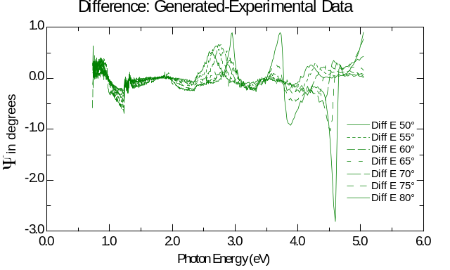

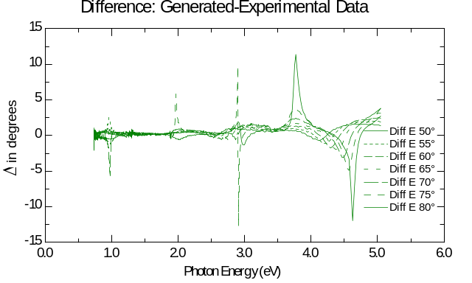

Bare_si_12222006

Variables fitted:

SiO₂ thickness: 2875.43 ± 0.065 Å
MSE = 18.47

OTS treated wafer reference #20

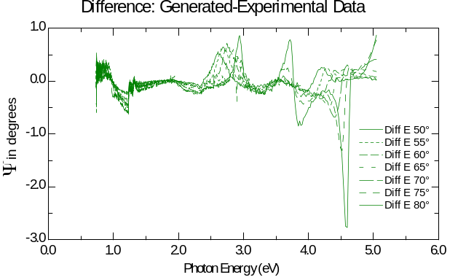

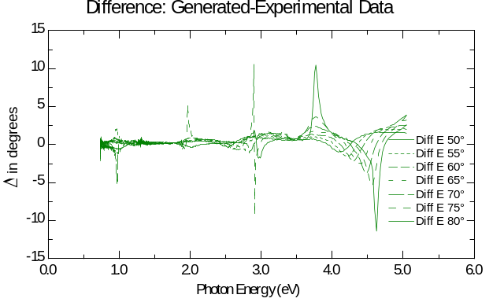
Ots_si_20_12222006

Variables fitted:

SiO₂ thickness: 2880.19 ± 0.0664 Å
MSE = 19.05

OTS treated wafer reference #25

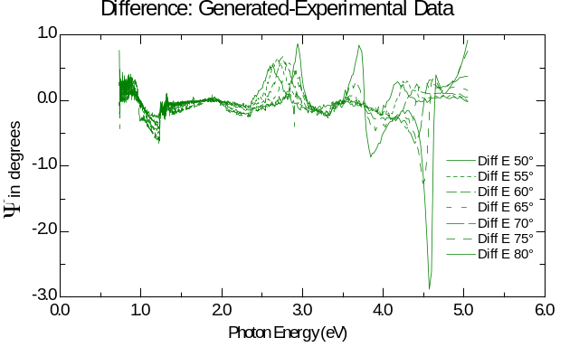

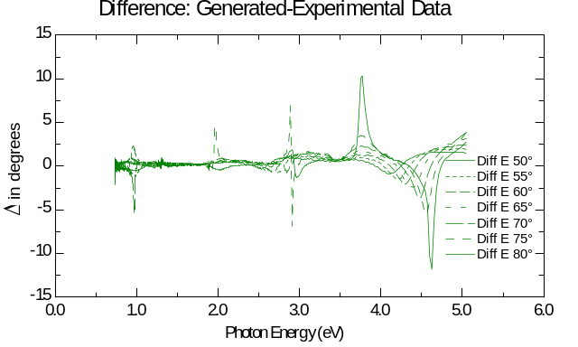

Ots_si_25_12222006

Variables fitted:

SiO₂ thickness: 2882.09 ± 0.0651 Å
MSE = 18.72

From this one can see that the increase in thickness from OTS treatment #20 was only 4.76 Å. For OTS treatment #25 the increase was 6.66 Å. Literature values for a densely packed OTS monolayer are on average at 25 Å. There is no indication that such a layer exists on these samples.

Using this approach on previous samples I get:

Parul_sio2_11022006

Variables fitted:
SiO₂ thickness: 2919.42 ± 0.0934 Å
MSE = 12.59

Parul_sio2_pt2_11022006

Variables fitted:
SiO₂ thickness: 2915.25 ± 0.102 Å
MSE = 14.41

Parul_ots_on_sio2_11022006

Variables fitted:
SiO₂ thickness: 2926.73 ± 0.122 Å
MSE = 16.48

Increase was 9.3950 Å from OTS treatment. Again a poor film is made.

I tried this method with OTS treatment of tantalum pentoxide. The gaussian oscillator model is used on all films.

P2_10202006

Ta2O5 thickness: 1810.74 ± 1.18 Å
Interface thickness: 21.15 ± 0.748 Å
MSE = 20.06

P2_10252006
With Cauchy layer: 6.42 ± 1.89 Å
Ta2O5 thickness: 1819.98 ± 1.09 Å 1817.42 ± 1.16 Å
Interface thickness: 20.85 ± 0.668 Å 21.39 ± 0.587 Å
MSE = 18.85 MSE = 18.3

P2_plasma_10252006

Ta2O5 thickness: 1822.83 ± 1.22 Å
Interface thickness: 20.21 ± 0.762 Å
MSE = 20.44

P2_ots_10242006

Ta2O5 thickness: 1820.10 ± 4.41 Å
Interface thickness: 27.27 ± 3.78 Å
MSE = 31.34

P2_ots2_10242006

Ta2O5 thickness: 1822.23 ± 2.62 Å
Interface thickness: 23.31 ± 2.01 Å
MSE = 28.9

P2_ots3_10242006
Cauchy Layer: 30.11 ± 2.58 Å
Ta2O5 thickness: 1819.36 ± 3.37 Å
Interface thickness: 18.15 ± 0.608 Å
MSE = 19.55

P2_ots4_10252006
With Cauchy Layer: 26.45 ± 3.3 Å
Ta2O5 thickness: 1822.23 ± 2.97 Å 1818.07 ± 3.49 Å
Interface thickness: 23.27 ± 2.36 Å 18.79 ± 0.636 Å
MSE = 29.23 MSE = 19.87

Using my Cauchy layer method I detect a 20 – 23.69 Å film of OTS on Ta₂O₅. Using only the Gaussian oscillator I get a difference of 2.25 Å. In this case adding the Cauchy layer shows a significant difference between treatments.

OTS on glass substrate

This is more difficult to measure since most of the information will be lost in transmission through the glass plate. Adding backside correction to the model only helps a little.

